ARYAMAN MISHRA

1)

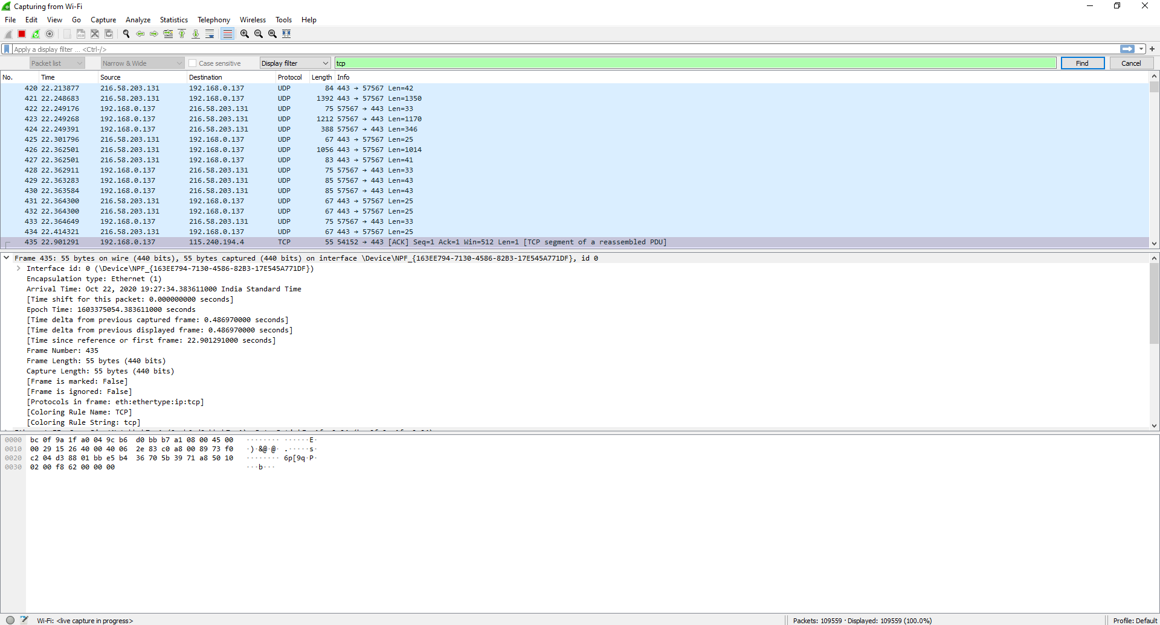

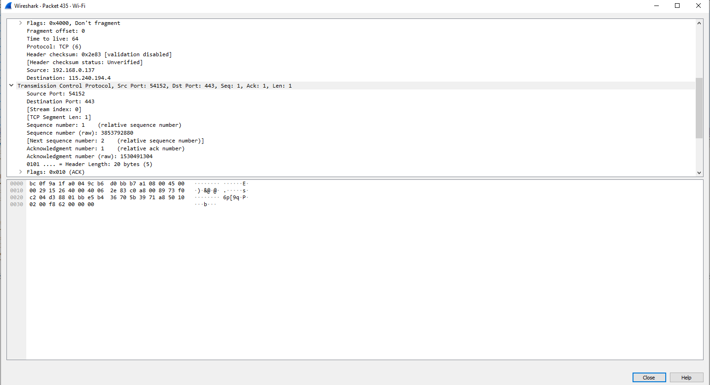

2)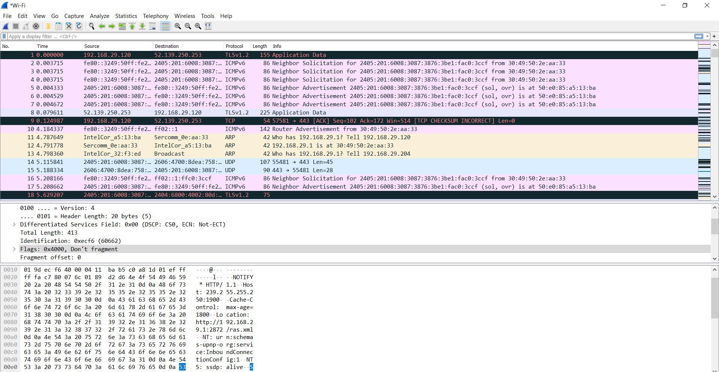

|  |  |  |
| --- | --- | --- |
| Source IP | 192.168  29.120 | C0 A8  00 89 |
| Destination IP | 115 240  194 4 | 73 F0  C2 04 |
| TCP Protocol | 0/6 | 06 |
| Padding | 0/10 | 16 |
| TCP src port | 443 | 1 BB |
| TCP dest port | 54152 | D3 88 |
| Seq Number | 1 | 00 01 |
| ACK number | 2 | 00 02 |
| Windows | 8030 | 1F5E |
| Flags |  | 00 10 |
| Final Value | EB | 97 |

3)

